KINDERGARTEN MATHEMATICS
UNIT 6 STANDARDS
Dear Parents,
As we shift to Common Core Standards, we want to make sure that you have an understanding of the mathematics your child will be learning this year. Below you will find the standards we will be learning in Unit Six. Each standard is in bold print and underlined and below it is an explanation with student examples. Your child is not learning math the way we did when we were in school, so hopefully this will assist you when you help your child at home. Please let your teacher know if you have any questions ☺

CCGPS.K.OA.2 Solve addition and subtraction word problems, and add and subtract within 10, e.g., by using objects or drawings to represent the problem.

This standard asks students to solve problems presented in a story format (context) with a specific emphasis on using objects or drawings to determine the solution. This objective builds upon their understanding of addition and subtraction from K.OA.1, to solve problems. Once again, numbers should not exceed 10.
Teachers should be cognizant of the three types of problems. There are three types of addition and subtraction problems: Result Unknown, Change Unknown, and Start Unknown. These types of problems become increasingly difficult for students. Research has found that Result Unknown problems are easier than Change and Start Unknown problems. Kindergarten students should have experiences with all three types of problems. The level of difficulty can be decreased by using smaller numbers (up to 5) or increased by using larger numbers (up to 10). Please see Appendix, Table 1 for additional examples.

CCGPS.K.OA.3 Decompose numbers less than or equal to 10 into pairs in more than one way, e.g., by using objects or drawings, and record each decomposition by a drawing or equation (e.g., 5 = 2 + 3 and 5 = 4 + 1).

This standard asks students to understand that a set of (5) object can be broken into two sets (3 and 2) and still be the same total amount (5). In addition, this objective asks students to realize that a set of objects (5) can be broken in multiple ways (3 and 2; 4 and 1). Thus, when breaking apart a set (decomposing), students develop the understanding that a smaller set of objects exists within that larger set (inclusion). This should be developed in context before moving into how to represent decomposition with symbols (+, -, =).

Example:
“Bobby Bear is missing 5 buttons on his jacket. How many ways can you use blue and red buttons to finish his jacket? Draw a picture of all your ideas. Students could draw pictures of:
•4 blue and 1 red button •3 blue and 2 red buttons •2 blue and 3 red buttons •1 blue and 4 red buttons

After the students have had numerous experiences with decomposing sets of objects and recording with pictures and numbers, the teacher eventually makes connections between the drawings and symbols: 5=4+1, 5=3+2, 5=2+3, and 5=1+4.

The number sentence only comes after pictures or work with manipulatives, and students should never give the number sentence without a mathematical representation.

CCGPS.K.OA.4 For any number from 1 to 9, find the number that makes 10 when added to the given number, e.g., by using objects or drawings, and record the answer with a drawing or equation.
This standard builds upon the understanding that a number can be decomposed into parts (K.OA.3). Once students have had experiences breaking apart ten into various combinations, this asks students to find a missing part of 10.
Example:
“A full case of juice boxes has 10 boxes. There are only 6 boxes in this case. How many juice boxes are missing?

Student 1  Using a Ten-Frame  I used 6 counters for the 6 boxes of juice still in the case. There are 4 blank spaces, so 4 boxes have been removed. This makes sense since 6 and 4 more equals 10. |  | Student 2  Think Addition  I counted out 10 cubes because I knew there needed to be ten. I pushed these 6 over here because there were in the container. These are left over. So there’s 4 missing. |  | Student 3  Basic Fact  I know that it’s 4 because 6 and 4 is the same amount as 10.

CCGPS.K.OA.5 Fluently add and subtract within 5.
Students are fluent when they display accuracy (correct answer), efficiency (a reasonable amount of steps in about 3 seconds without resorting to counting), and flexibility (using strategies such as the distributive property). Students develop fluency by understanding and internalizing the relationships that exist between and among numbers. Oftentimes, when children think of each “fact” as an individual item that does not relate to any other “fact”, they are attempting to memorize separate bits of information that can be easily forgotten. Instead, in order to fluently add and subtract, children must first be able to see sub-parts within a number (inclusion, K.CC.4.c). Once they have reached this milestone, children need repeated experiences with many different types of concrete materials (such as cubes, chips, and buttons) over an extended amount of time in order to recognize that there are only particular sub-parts for each number. Therefore, children will realize that if 3 and 2 is a combination of 5, then 3 and 2 cannot be a combination of 6. For example, after making various arrangements with toothpicks, students learn that only a certain number of sub-parts exist within the number 4:
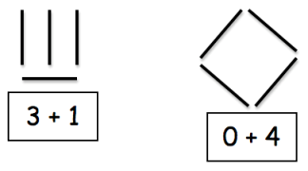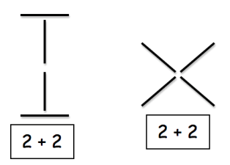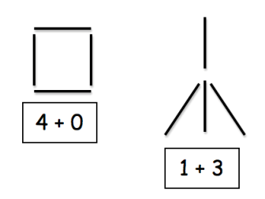

Then, after numerous opportunities to explore, represent and discuss “4”, a student becomes able to fluently answer problems such as, “One bird was on the tree. Three more birds came. How many are on the tree now?” and “There was one bird on the tree. Some more came. There are now 4 birds on the tree. How many birds came?” Traditional flash cards or timed tests have not been proven as effective instructional strategies for developing fluency.* Rather, numerous experiences with breaking apart actual sets of objects help children internalize parts of number.

